**Logitec Group Infrared Transmission Protocol**

Author: Starovierov Kostiantyn

Date: 2016/10/26

Revision: V1

**1. Logitec protocol is based on** [**NEC protocol**](https://sibotic.files.wordpress.com/2013/12/adoh-necinfraredtransmissionprotocol-281113-1713-47344.pdf)

The NEC IR transmission protocol uses pulse distance encoding of the message bits. Each pulse burst (mark – RC transmitter ON) is 562.5µs in length, at a carrier frequency of 38kHz (26.3µs). Logical bits are transmitted as follows:

* Logical '0' – a 562.5µs pulse burst followed by a 562.5µs space, with a total transmit time of 1.125ms
* Logical '1' – a 562.5µs pulse burst followed by a 1.6875ms space, with a total transmit time of 2.25ms

When transmitting or receiving remote control codes using the NEC IR transmission protocol, the WB_IRRC performs optimally when the carrier frequency (used for modulation/demodulation) is set to 38.222kHz.

When a key is pressed on the remote controller, the message transmitted consists of the following, in order:

* 9ms leading pulse burst (16 times the pulse burst length used for a logical data bit)
* a 4.5ms space
* the 8-bit address for the receiving device
* the 8-bit logical inverse of the address
* the 8-bit command
* the 8-bit logical inverse of the command
* a final 562.5µs pulse burst to signify the end of message transmission.

The four bytes of data bits are each sent least significant bit first. Figure 1 illustrates the format of an NEC IR transmission frame, for an address of 00h (00000000b) and a command of ADh (10101101b).

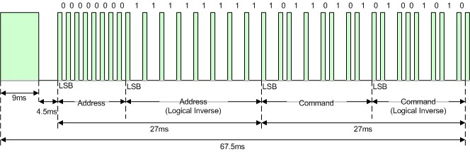

Figure 1. Example message frame using the NEC IR transmission protocol.

Notice from Figure 1 that it takes:

* 27ms to transmit both the 16 bits for the address (address + inverse) and the 16 bits for the command (command + inverse). This comes from each of the 16 bit blocks ultimately containing eight '0's and eight '1's - giving (8 * 1.125ms) + (8 * 2.25ms).
* 67.5ms to fully transmit the message frame (discounting the final 562.5µs pulse burst that signifies the end of message).

**Repeat Codes**

If the key on the remote controller is kept depressed, a repeat code will be issued, typically around 40ms after the pulse burst that signified the end of the message. A repeat code will continue to be sent out at 108ms intervals, until the key is finally released. The repeat code consists of the following, in order:

* a 9ms leading pulse burst
* a 2.25ms space
* a 562.5µs pulse burst to mark the end of the space (and hence end of the transmitted repeat code).

Figure 2 illustrates the transmission of two repeat codes after an initial message frame is sent.

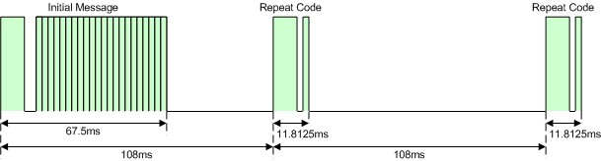

Figure 2. Example repeat codes sent for a key held down on the transmitting remote controller.

**2. Logitec Group IR address and commands**

Address and command values used by Logitech are listed in the table bellow.

| Key | | ADDRESS | | /ADDRESS | | DATA | | /DATA | |
| --- | --- | --- | --- | --- | --- | --- | --- | --- | --- |
| BIN | HEX | BIN | HEX | BIN | HEX | BIN | HEX |
|  | Call answer | 00000010 | 02 | 11111101 | FD | 11100110 | E6 | 00011001 | 19 |
|  | Call end | 00000010 | 02 | 11111101 | FD | 11110110 | F6 | 00001001 | 09 |
|  | Volume down | 00000010 | 02 | 11111101 | FD | 01101010 | 6A | 10010101 | 95 |
|  | Volume Up | 00000010 | 02 | 11111101 | FD | 10101010 | AA | 01010101 | 55 |
|  | Mute | 00000010 | 02 | 11111101 | FD | 11101010 | EA | 00010101 | 15 |
|  | Camera Up | 00000010 | 02 | 11111101 | FD | 10100110 | A6 | 01011001 | 59 |
|  | Camera Down | 00000010 | 02 | 11111101 | FD | 10110110 | B6 | 01001001 | 49 |
|  | Camera Left | 00000010 | 02 | 11111101 | FD | 10101110 | AE | 01010001 | 51 |
|  | Camera Right | 00000010 | 02 | 11111101 | FD | 10111110 | BE | 01000001 | 41 |
|  | Zoom in | 00000010 | 02 | 11111101 | FD | 10100011 | A3 | 01011100 | 5C |
|  | Zoom out | 00000010 | 02 | 11111101 | FD | 11100011 | E3 | 00011100 | 1C |
|  | Near/Far camera control | 00000010 | 02 | 11111101 | FD | 11111010 | FA | 00000101 | 05 |
|  | Key1 | 00000010 | 02 | 11111101 | FD | 10101100 | AC | 01010011 | 53 |
|  | Key2 | 00000010 | 02 | 11111101 | FD | 01101100 | 6C | 10010011 | 93 |
|  | Key3 | 00000010 | 02 | 11111101 | FD | 11101100 | EC | 00010011 | 13 |
|  | Key4 | 00000010 | 02 | 11111101 | FD | 01001100 | 4C | 10110011 | B3 |
|  | Key5 | 00000010 | 02 | 11111101 | FD | 00101100 | 2C | 11010011 | D3 |

